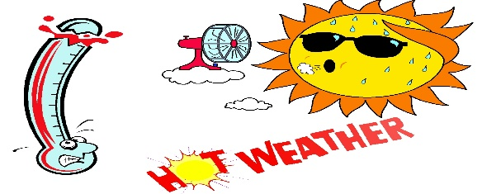
This Photo by Unknown Author is licensed under CC BY-NC-ND
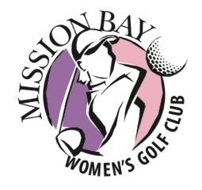
QUE PASA
An occasional missive to the members of the Mission Bay Women’s Golf Club

BIRTHDAY GREETINGS: August birthdays include: Nancy Babos, Lee Ann Cusick, Shirley Rehkopf, and Carol Sorenson. May your drives be straight and long and you score no worse than par!

On the DL: Barbara Dinsmore is nursing a sore shoulder. An e-card to cheer her was sent last week. Hope you feel better soon, Barb, and can rejoin us. We miss you.
Doris Cronkhite continues to recover from her stroke. Fight on, Doris!

Housekeeping: Now that we have seven or more groups playing, please remember to keep the pace of play moving. We want the pro shop happy with giving us the shotgun start that allows us to finish as a group.

It might be helpful to the new members to have a veteran player explain how we fill out the scorecard—name alphabetically, record score on the next hole, no putts on the Ringer card, and how to pay the “piggies.”

Soon sign-up for the following week’s play will be done on line exclusively. Please familiarize yourself with the process. If you are unsure how to sign up on-line, ask someone for assistance.

Weather Alert: It’s hot out there!
Stay hydrated. If you feel any symptoms of heat exhaustion—light headedness, fatigue, dizziness. STOP, seek shade, drink water, and/or seek help. Golf is not so important as to endanger your health. We have all reached the age of wisdom—use that wisdom to stay safe in the hot weather.

